Sam Sample - 2023
Positions:
Defender, Midfielder
Team Name: Rio Rapids SC ECNL 05
Club colors: Burgundy and white
PERSONAL
Height: 5”7” Weight: 130 lb.
Address: 5555 Street Address NE
Albuquerque, NM 87122
Email: playeremail@gmail.com
Cell: 505-555-5555 Home: 505-555-5555
Parents: Dad’s Name, Mom’s Name
Your High School
ACADEMICS
Albuquerque, NM 87122
Phone: 505-555-5555

Date of Graduation: 2023
GPA: x.x /4.0 Class Rank: xx/yyy
SAT Score: Taking January 2020 or score
ACT Score: To be scheduled or score
PSAT Score: if SAT and ACT not available

Honors/AP Classes

Academic Accomplishments and Awards
(Reverse Chronological/Most Prestigious)

Academic Programs of Interest: Education, Engineering
Name, Role (club team coach)
REFERENCES
505-555-5555 reference@msn.com
Name, Role (high school coach)
505-555-5555 reference@gmail.com

Name, Role (other coach)
505-555-5555 reference@gmail.com
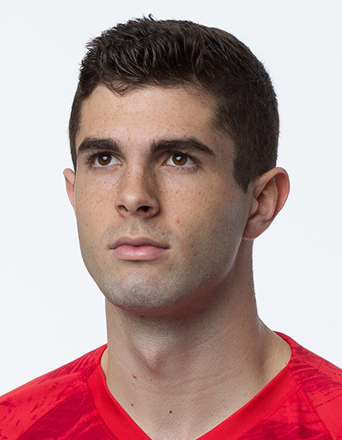

Club Team - Rio Rapids SC 04 (#10):
soccer
2015-Present
2019 NM State Champions
2019 Far West Regionals - Quarterfinalist
2019 Las Vegas Players Showcase
2018 Surf College Cup – Champions
2017-18 Desert Conference 4th Place

Your High School (#7):
Varsity: 2019 & 2018 JV: 2017
Team and Individual Accomplishments (Reverse Chronological/Most Prestigious)

DA/ECNL/ODP/id2:
2017-18 Colorado Rapids DA GA Event
2018-19 ECNL Discovery Player
2017-Present NM ODP Team
2015 & 2016 Varsity Track:
Other Sports
200 meters & 4 x 400 relay
clubs / volunteering
Volunteer or Community Service Activities

Other Activities and Leadership Roles

Unique Personal Interests or Hobbies

